**MERN Stack Training**

**React Tasks**

**1.How to write your first React component**

**Task 1:**Create a simple functional component named Greeting that returns “Hello, World!” within a tag.

function Greeting(){

    return (

        <h1>Hello, World!</h1>

    )

}

export default Greeting;

**App.js:**

import Greeting from './t1';

function App() {

  return (

    <Greeting/>

  );

}

export default App;

**OUTPUT:**

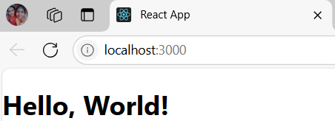

**Task 2:** Modify the Greeting component to display “Hello, React!”.

function Greeting(){

    return (

        <h1>Hello, React!</h1>

    )

}

export default Greeting;

**OUTPUT:**

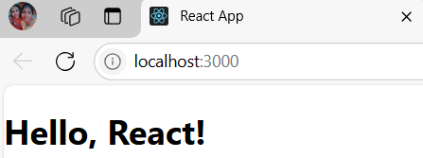

**Task 3:** Create a Gallery functional component to display an image.

function Gallery(){

    return(

        <img src='./moon.jpeg'></img>

    )

}

export default Gallery;

App.js

import Gallery from './t3';

function App() {

  return (

    <Gallery/>

  );

}

export default App;

**OUTPUT:**

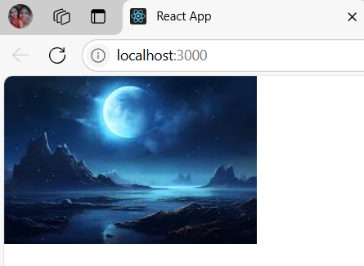

**Task 4:** Add Greeting to the Gallery component and display the image and greeting.

import React from "react";

import Greeting from "./Greeting";

const Gallery=()=>{

    return (

    <div>

    <img src="./moon.jpeg" alt='moon'/>

    <Greeting text="Hello, world!" />

    </div>

    )

}

export default Gallery;

**App.js**

import Greeting from './Greeting';

import Gallery from "./Gallery";

import Profiles from"./Profiles";

function App() {

  return (

    <Gallery/>

  );

}

**OUTPUT:**

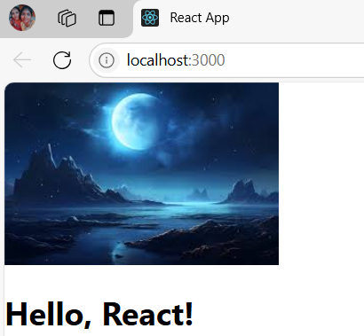

**Task 5:** Write a component called Profile which displays a hardcoded user’s name and age.

const Profiles=()=>{

    const name="Anu";

    const age=20;

    return(

        <div>

            <h1>Profile</h1>

            <h3>Name:{name}</h3>

            <h3>Age:{age}</h3>

        </div>

    )

}

export default Profiles;

App.js

import Greeting from './Greeting';

import Gallery from "./Gallery";

import Profiles from"./Profiles";

function App() {

  return (

    <Profiles/>

  );

}

export default App;

**OUTPUT:**

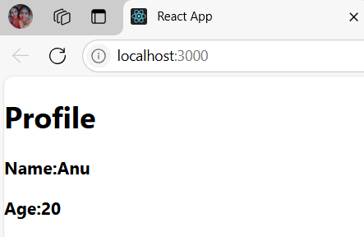

**2.When and how to create multi-component files**

**Task 1:** Create a file named UserComponents.js and inside it, define two components: UserName and UserAge that display hardcoded names and ages respectively.

**Task 2:** Export both UserName and UserAge from UserComponents.js**.**

**Task 3:** In a separate file, import and use both UserName and UserAge components using named imports.

const UserName=()=>{

    const name="Anu";

    return <h3>Name:{name}</h3>

}

const UserAge=()=>{

    const age=20;

    return <h3>Age:{age}</h3>

}

export {UserAge,UserName};

App.js:

import Greeting from './Greeting';

import Gallery from "./Gallery";

import Profiles from"./Profiles";

import {UserName,UserAge} from"./UserComponents";

function App(){

  return(

    <>

    <UserName/>

    <UserAge/>

    </>

  )

}

export default App;

**OUTPUT:**

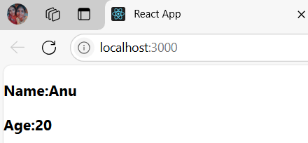

**Task 4:** Convert UserAge into a default export and modify the importing file to accommodate the change.

**Task 5:** Split UserName and UserAge into separate files and adjust your imports.

const UserName=()=>{

    const name="Anu";

    return <h3>Name:{name}</h3>

}

export default UserName;

const UserAge=()=>{

    const age=20;

    return <h3>Age:{age}</h3>

}

export default UserAge;

App.js:

import Greeting from './Greeting';

import Gallery from "./Gallery";

import Profiles from"./Profiles";

//import {UserName,UserAge} from"./UserComponents";

import UserName from"./UseName";

function App(){

  return(

    <UserName/>

  );

}

function App(){

  return(

    <UserAge/>

  );

}

export default App;

**OUTPUT:**

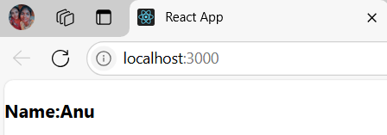

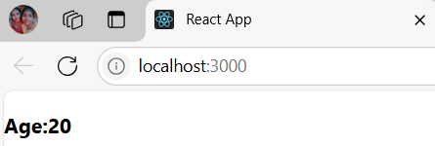

**3.How to add markup to JavaScript with JSX**

**Task 1:** Create a component that displays an unordered list (<ul>) of 3 favorite fruits.

//Markup js to jsx task1

const Fruits=()=>{

    return(

        <div>

            <h1>My Favourite Fruits</h1>

            <ul>

                <li>Mango</li>

                <li>Orange</li>

                <li>Pomogranate</li>

            </ul>

        </div>

    )

}

export default Fruits;

App.js:

import Greeting from './Greeting';

import Gallery from "./Gallery";

import Profiles from"./Profiles";

//import {UserName,UserAge} from"./UserComponents";

import UserName from"./UseName";

import UserAge from"./UserAge";

import Fruits from "./Fruits";

function App(){

  return(

    <Fruits/>

  );

}

export default App;

**OUTPUT:**

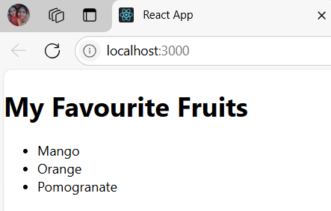

**Task 2:** Update the above component to display a picture (<img>) of each fruit next to its name. (Use hardcoded image URLs for now.)

const Fruits=()=>{

    return(

        <div>

            <h1>My Favourite Fruits</h1>

            <ul>

                <li>

                    <img src="./mango.jpg" alt="Mango" style={{width:'25px',height:'25px',marginRight:'8px'}}/>

                    Mango

                </li>

                <li>

                    <img src="./orange.jpg" alt="Orange" style={{width:'25px',height:'25px',marginRight:'8px'}}/>

                    Orange

                </li>

                <li>

                    <img src="./pom.jpg" alt="Pomogranete" style={{width:'25px',height:'25px',marginRight:'8px'}}/>

                    Pomogranate

                </li>

            </ul>

        </div>

    )

}

export default Fruits;

App.js:

import Greeting from './Greeting';

import Gallery from "./Gallery";

import Profiles from"./Profiles";

//import {UserName,UserAge} from"./UserComponents";

import UserName from"./UseName";

import UserAge from"./UserAge";

import Fruits from "./Fruits";

function App(){

  return(

    <Fruits/>

  );

}

export default App;

**OUTPUT:**

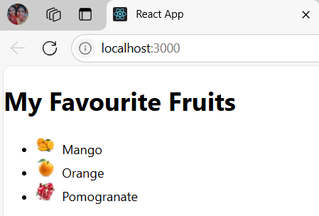

**Task 3:** Create a component WebsiteLink that displays a hardcoded URL in an anchor (<a>) tag.

const WebsiteLink=()=>{

    return(

        <div>

        <a href="www.google.com" rel="google" target="_blank">Google</a>

        </div>

    )

}

export default WebsiteLink;

App.js:

import Greeting from './Greeting';

import Gallery from "./Gallery";

import Profiles from"./Profiles";

//import {UserName,UserAge} from"./UserComponents";

import UserName from"./UseName";

import UserAge from"./UserAge";

import Fruits from "./Fruits";

import WebsiteLink from"./WebsiteLink";

function App(){

  return(

    <WebsiteLink/>

  );

}

export default App;

**OUTPUT:**

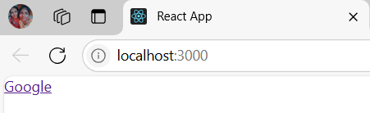

**Task 4:** Make a JSX component that mimics a simple blog post with a title, content, and author. (All hardcoded.)

const BlogPost=()=>{

    return(

        <div style={{border:'2px solid pink',maxHeight:'700px',width:'400px',margin:'1px 1px',padding:'10px'}}>

            <h2 style={{textAlign:'center',color:'blue'}}>React Js</h2>

            <p>

            React is a JavaScript library for building user interfaces. React is used to build single-page applications. React allows us to create reusable UI components.

            </p>

            <i>by Anu</i>

        </div>

    )

}

export default BlogPost;

App.js:

import BlogPost from"./BlogPost";

function App(){

  return(

    <BlogPost/>

  );

}

export default App;

**OUTPUT:**

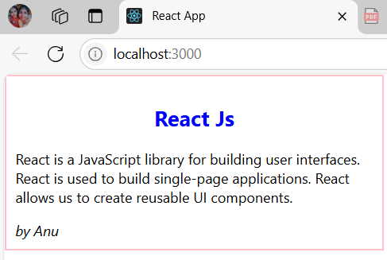

**Task 5:** Design a Footer component with hardcoded copyright information using JSX.

const Footer=()=>{

    return(

        <footer style={{marginTop:'5px',textAlign:'left'}}>CopyRight &copy; 2025.All rights are reserved</footer>

    )

}

export default Footer;

App.js:

import Footer from"./Footer";

function App(){

  return(

    <Footer/>

  );

}

export default App;

**OUTPUT:**

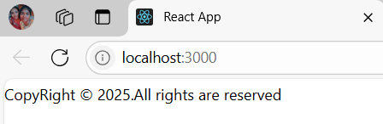

**4.** **JavaScript in JSX with Curly Braces**

**Task 1:** Display today’s date in a component using the JavaScript Date object**.**

const TodaysDate=()=>{

    const date=new Date();

    const d=date.toDateString();

    return(

        <h1>{d}</h1>

    )

}

export default TodaysDate;

App.js:

import TodaysDate from"./TodaysDate";

function App(){

  return(

    <TodaysDate/>

  );

}

export default App;

**OUTPUT:**

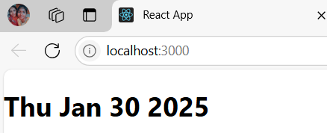

**Task 2:** Create a component that displays a random quote from a hardcoded list of quotes.

const RandomQuotes=()=>{

    const quotes=["Everything you've ever wanted is sitting on the other side of fear",

                  "The question isn't who is going to let me; it's who is going to stop me",

                  "Every strike brings me closer to the next home run",

                  "Don't worry about failure; you only have to be right once"

                 ];

    let random=Math.floor(Math.random()*(quotes.length+1));

    return (

        <i>{quotes.at(random)}</i>

    )

}

export default RandomQuotes;

App.js:

import RandomDates from"./RandomDates";

function App(){

  return(

    <RandomDates/>

  );

}

export default App;

**OUTPUT:**

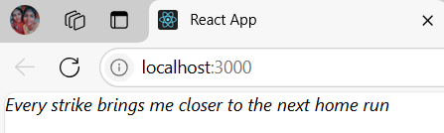

**Task 3:** Write a component called MathResult that displays the result of a simple arithmetic operation (e.g., addition) of two hardcoded numbers.

const MathResult=()=>{

    const a=10,b=20;

    return(

        <h1>Sum of {a} and {b} is {a+b}</h1>

    )

}

export default MathResult;

App.js:

import MathResult from"./MathResult";

function App(){

  return(

    <MathResult/>

  );

}

export default App;

**OUTPUT:**

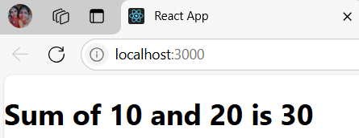

**Task 4:** Create a component that displays the word count of a hardcoded paragraph.

const WordCount=()=>{

    const para="No matter how hard he tried, he couldn't give her a good explanation about what had happened. It didn't even really make sense to him"

    const arr=para.split(" ");

    const num=arr.length;

    return(

        <h1>Number of Words in the paragraph {num}</h1>

    )

}

export default WordCount;

App.js:

import WordCount from"./WordCount";

function App(){

  return(

    <WordCount/>

  );

}

export default App;

**OUTPUT:**

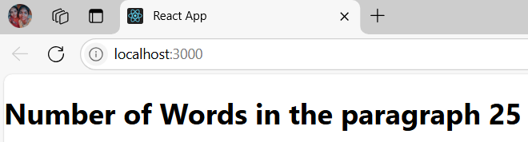

**Task 5:** Create a component that calculates and displays the product of two hardcoded numbers**.**

const Product=()=>{

    const a=10,b=20;

    return(

        <h1>Product of {a} and {b} is {a*b}</h1>

    )

}

export default Product;

**App.js:**

import Product from"./Product";

function App(){

  return(

    <Product/>

  );

}

export default App;

**OUTPUT:**

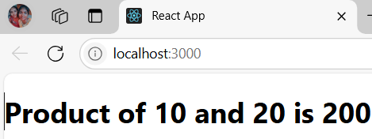

**5.Passing Props to a Component**

**Task 1:** Create a Movie component that displays the title, year, and rating of a movie using props.

export default function Movie(props){

    const title=props.title;

    const year=props.year;

    const rating=props.rating;

    return(

     <>

     <h3>The Movie Title <section style={{color:'blue'}}>{title}</section></h3>

     <h3>Year of released <section style={{color:'blue'}}>{year}</section></h3>

     <h3>Rating <section style={{color:'blue'}}>{rating}</section></h3>

     </>

    )

 }

**App.js;**

import Movie from './Movie';

function App(){

  return(

    <Movie/>

  );

}

export default App;

**OUTPUT:**

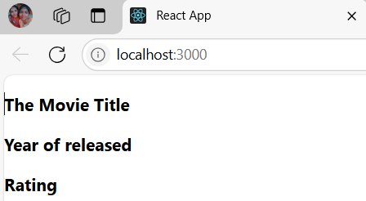

**Task 2:** Update the Movie component to have a default prop for rating as “Not Rated”.

export default function DefaultMovie({title,year,rating=10}){

    return(

     <>

     <h3>The Movie Title <section style={{color:'blue'}}>{title}</section></h3>

     <h3>Year of released <section style={{color:'blue'}}>{year}</section></h3>

     <h3>Rating <section style={{color:'blue'}}>{rating}</section></h3>

     </>

    )

 }

App.js:

import DefaultMovie from './DefaultMovie';

function App(){

  return(

    <DefaultMovie/>

  );

}

export default App;

**OUTPUT:**

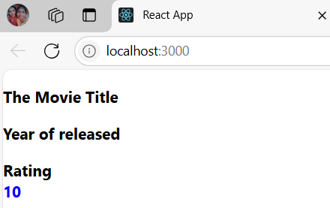

**Task 3:** Design a Button component that takes in a label prop and displays the label on the button.

export default function Button({label}){

    return(

     <button>{label}</button>

    )

 }

App.js:

import Button from './Button';

function App(){

  return(

    <Button/>

  );

}

export default App;

**OUTPUT:**

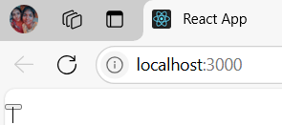

**Task 4:** Make a UserProfile component and pass an object containing user details as props and display them.

const UserProfile=({user})=>{

    return(

        <>

        <h3>User Name:{user.name}</h3>

        <h3>User Age:{user.age}</h3>

        <h3>User Gender:{user.gender}</h3>

        <h3>User is Married:{user.isMarried===true?"Yes":"No"}</h3>

        </>

    )

}

export default UserProfile;

App.js:

import UserProfile from './UserProfile';

function App(){

  return(

    <UserProfile/>

  );

}

export default App;

**OUTPUT:**